# CS 255 System Design Document Template

This template lays out all the different sections that you need to complete for Project Two. Each section has guidance to prompt your thinking. You will need to continually reference the interview transcript as you work to make sure that you are addressing your client’s needs. There is no required length for the final document. Instead the goal is to complete each section based on what your client’s needs are. Remove this note when you are finished, and replace all bracketed text with the relevant information.

## UML Diagrams

### UML Use Case Diagram

### UML Activity Diagrams

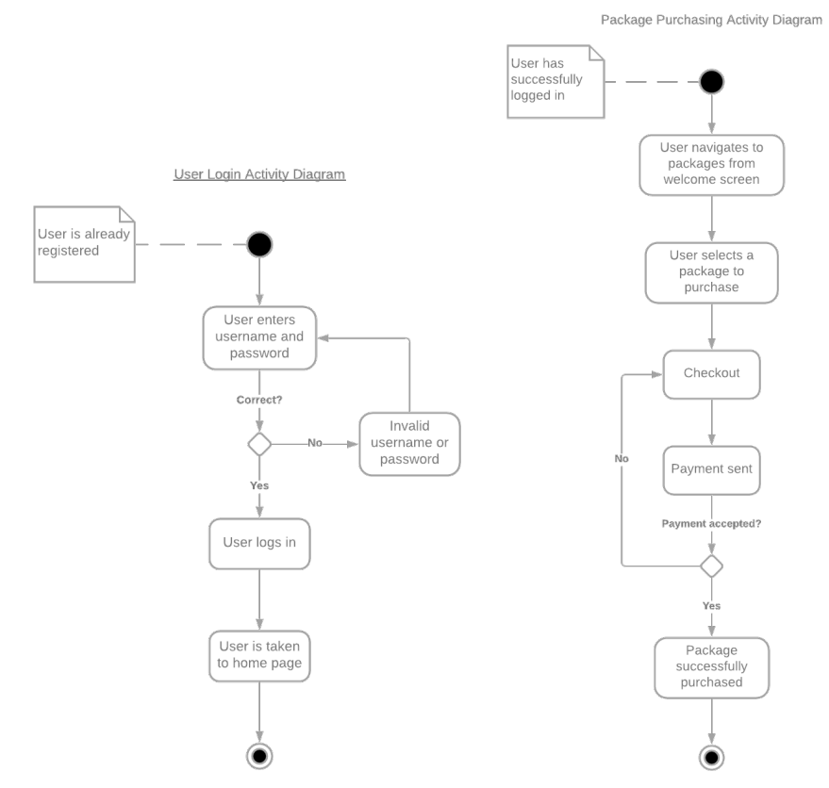

### UML Sequence Diagram

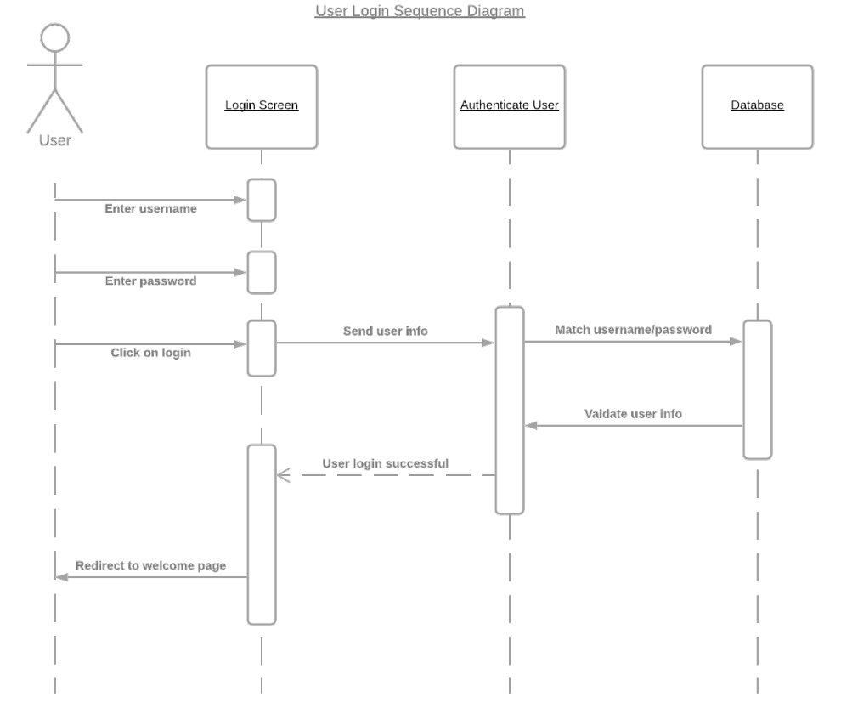

### UML Class Diagram

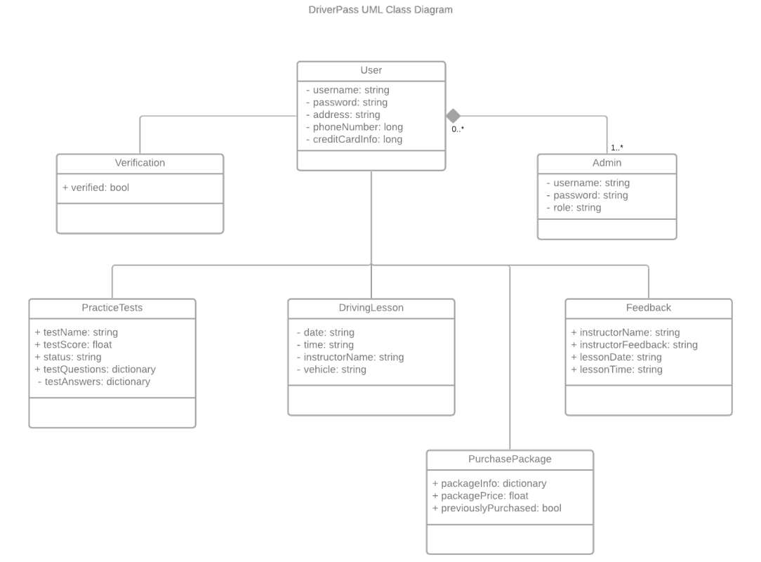

## Technical Requirements

*The DriverPass platform will be an online application built with Python and hosted on a cloud service. This service will store the database with user login details, the server-side code, and the primary Python programming. Will need to support SHA 256bit encryption for security for user needs as well as data integrity.*